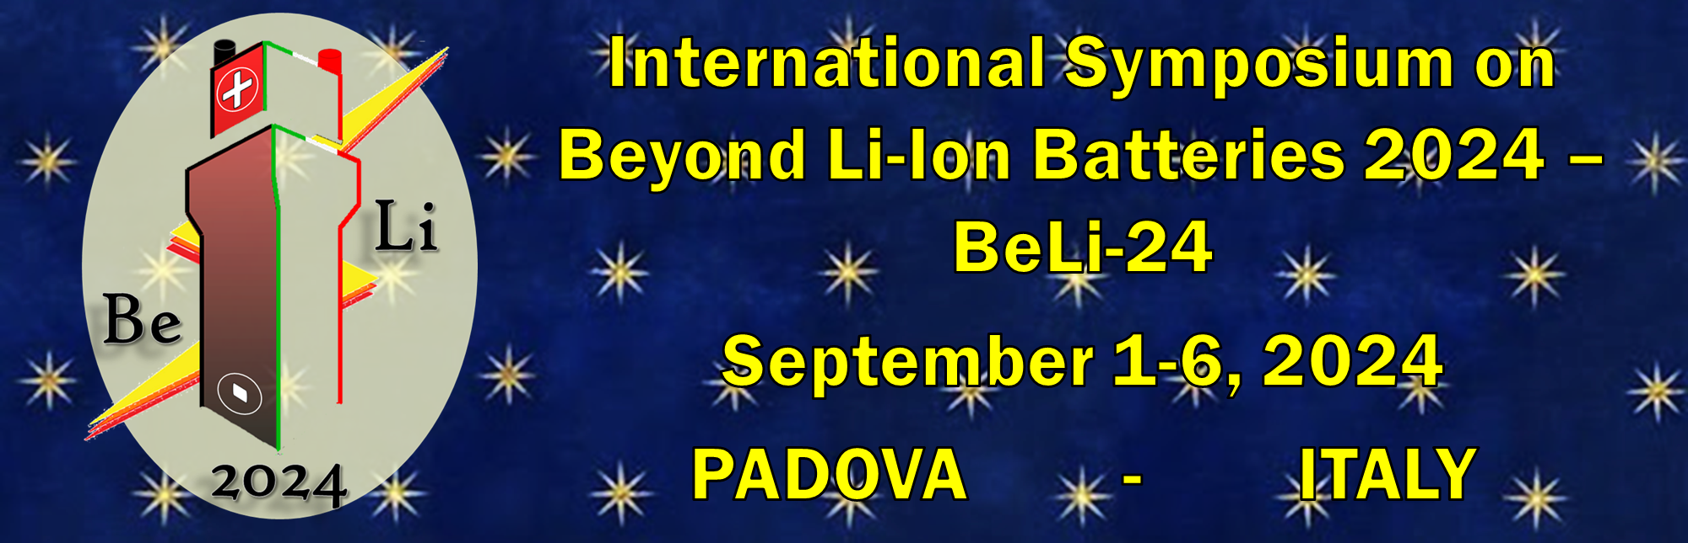
AbanoTerme, Italy ……………………, 2024
For the attention of:
Italian Embassy of………… ………
Fax ……………………………… .………
Email ………………………………………
Dear Sirs,

on behalf of the Organizing Committee, we extend our cordial invitation to Mr/Mrs ……………………………… to participate in the International Symposium on Beyond Li-Ion Batteries 2024 (BeLI24) that will be held in Padua, Italy, on 1-6 September 2024.

BeLI24 is a world-class meeting meant to convene in Padova the international scientific community active at the global level in the research of all the fundamental and applied aspects of materials for beyond Li-ion batteries. Materials for solid-state and high voltage batteries, lithium metal batteries and batteries exploiting chemistries not relying on lithium ion will be considered. BeLI24 will be is also focused on the experimental and the theoretical/computational aspects of the materials, such as the mechanisms of charge migration, the interactions and the reactions at the various electrochemical interfaces, and the cyclability and performance in batteries. In addition, BeLI24 will examine the safety and the circular economy of beyond Li-ion batteries, including the disassembly, the recovering/recycling and the life-cycle assessment of the materials and components. Finally, BeLI24 will explore all the aspects of redox flow batteries.

All relevant information on BeLI24 is available on https://projects.dii.unipd.it/beli24/
His/Her contribution to the Conference will not only mutually benefit all participants but also help to make this event a success. Your support in issuing the entry visas to Italy would be most appreciated.
Personal data of ………………………… as follows:

Passport No.:
Valid Until:
Issued By:
First Name:
Nationality:
Family Name:
Date of Birth:
Place of Birth:
Sex:

This letter does not constitute any financial obligation on behalf of the Organizers.

Sincerely yours,
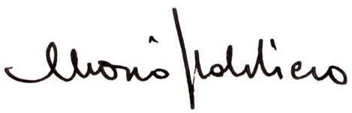

Mario Sbalchiero

Meet and Work Srl
BeLI24 Organising Secretariat
Piazza del Sole e della Pace, 5
I-35031 Abano Terme PD
Tel +39 049 860 1818
www.meetandwork.it - e-mail: meet@meetandwork.com

